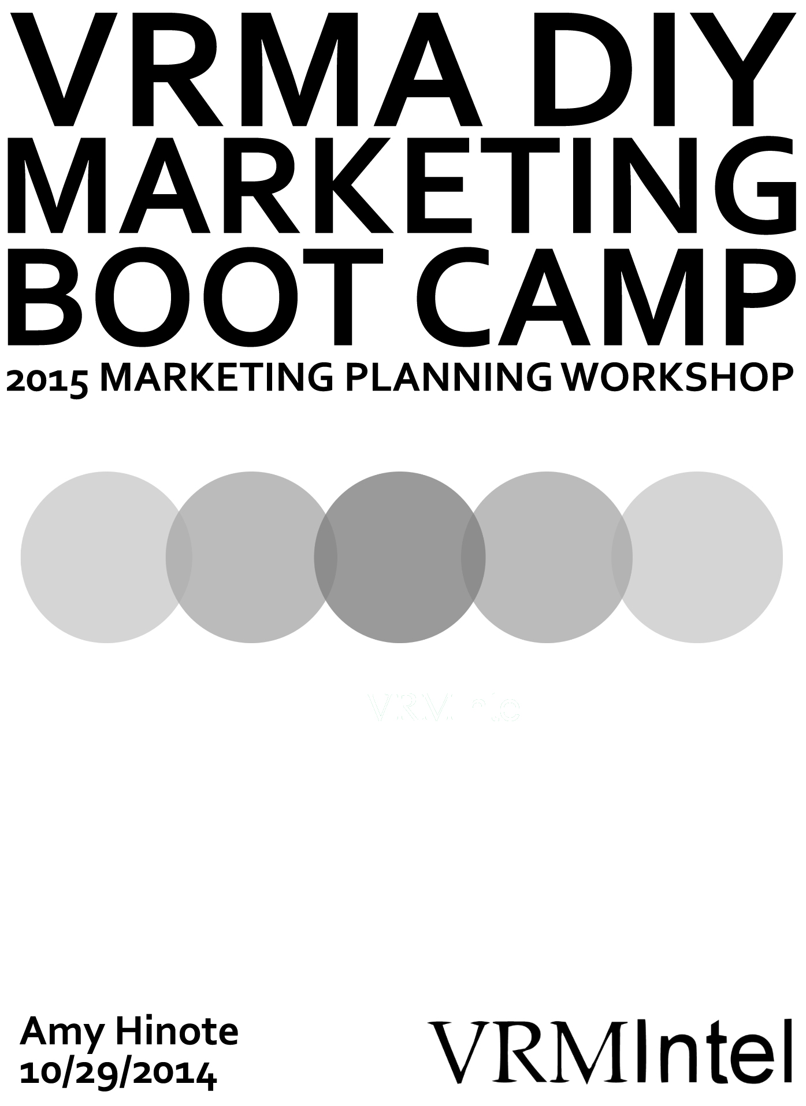WELCOME TO your vacation rental marketing planning workshop
Be prepared for brainstorming and hands-on fun.

Hello, Vacation Rental Peeps!
Welcome to the first VRMA Marketing Boot Camp

One of the most important steps you can take in implementing an effective and efficient marketing strategy is developing a written marketing plan.
This plan will guide your marketing decisions and assist in allocating marketing resources such as money and personnel time.

SESSION BASICS
> Your vacation rental marketing planning process:
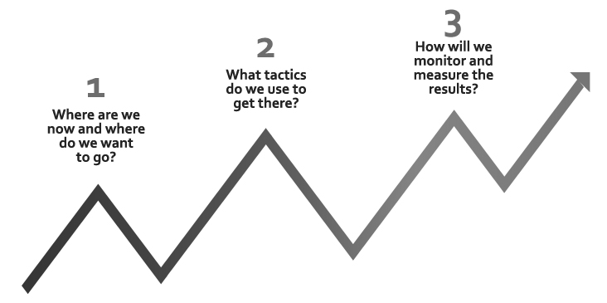

TIMELINE / AGENDA
> This is what we will do this afternoon
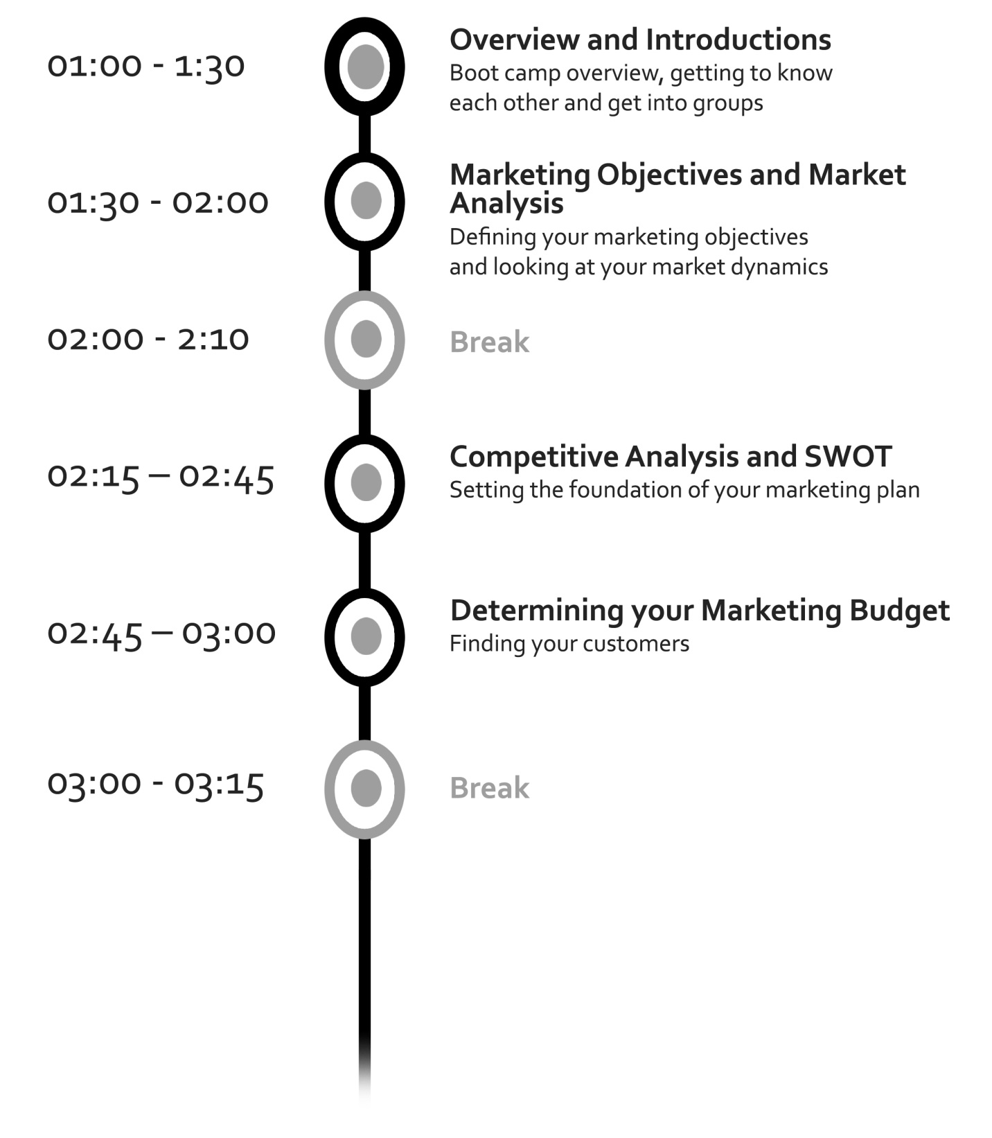

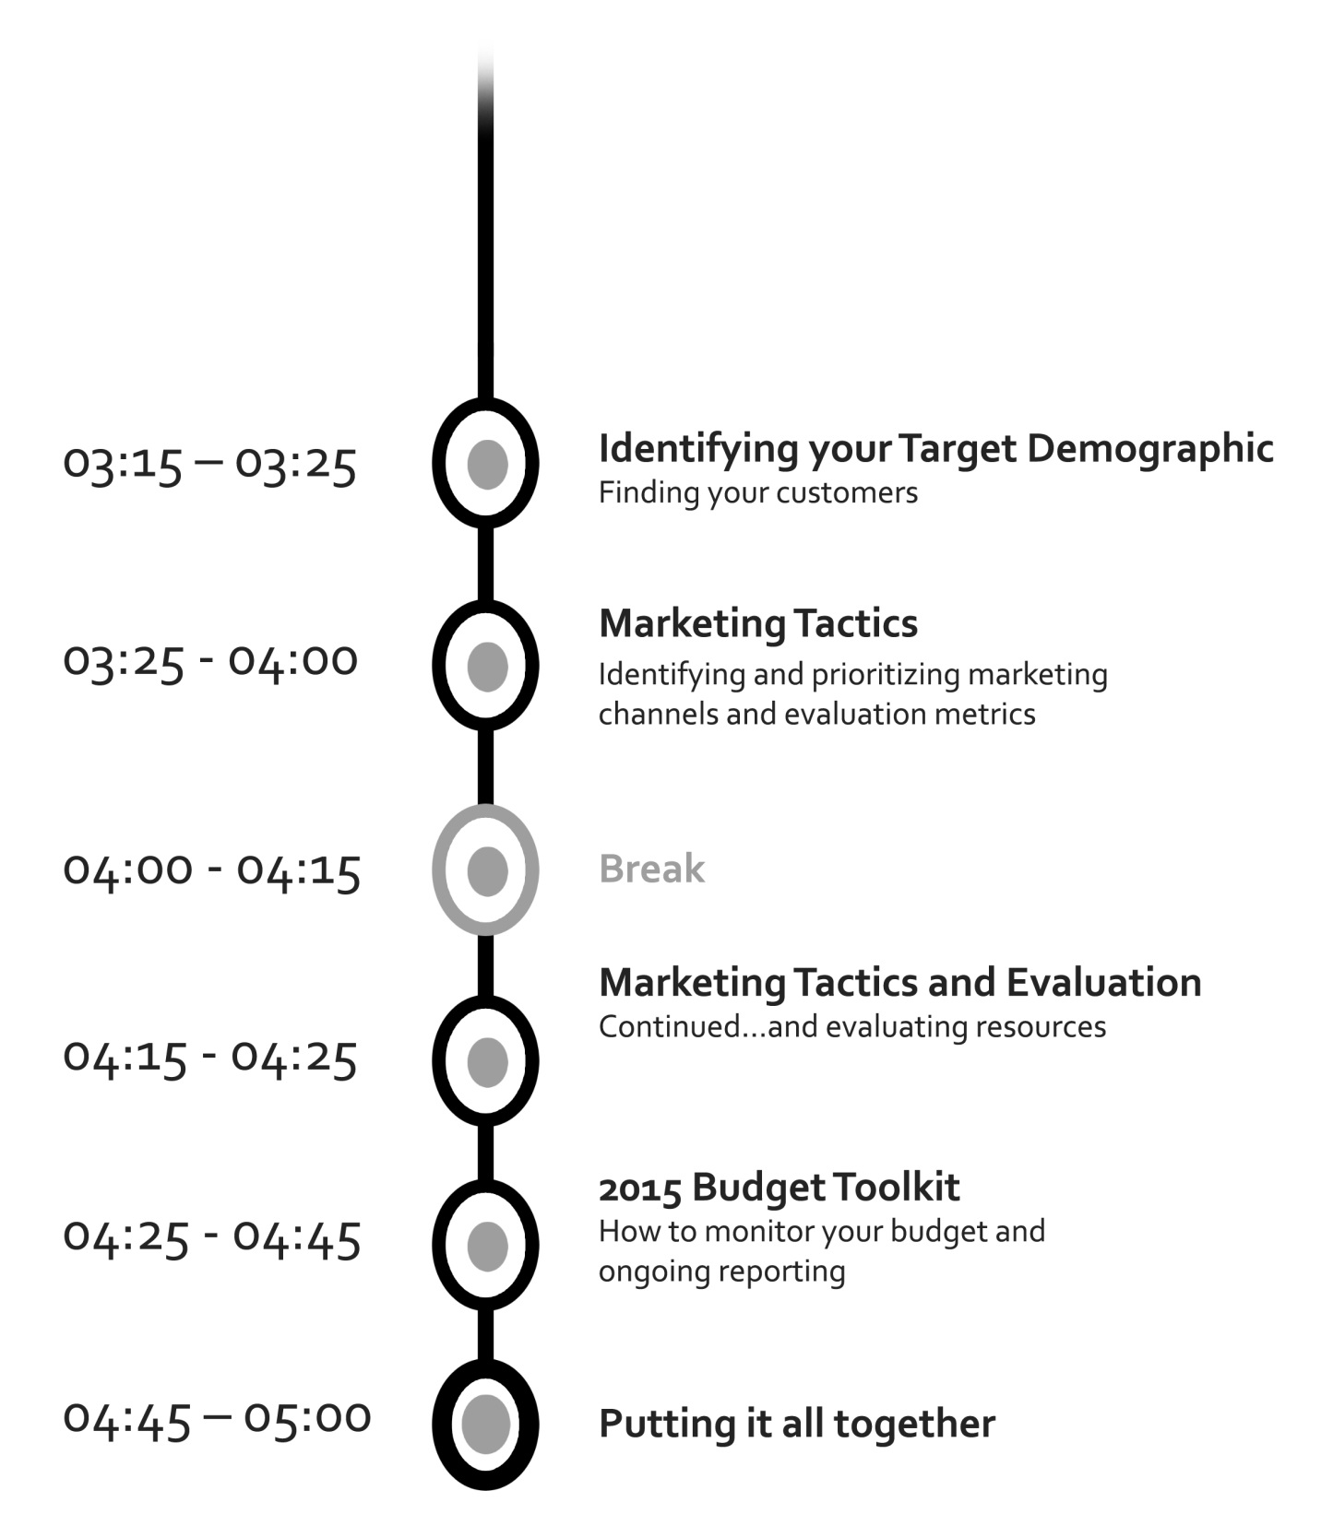

Vacation Rental Marketing Plan Outline Structure

  - Executive Summary
  - Overall Business Objectives
  - Market Analysis
    - Area
    - Competitive
    - Pricing
  - Company Analysis
    - SWOT
    - Target Demographic
  - Marketing Strategy
    - Content Marketing
    - Online Tactics
      - Website
      - SEO
      - PPC
      - Social
      - Online Advertising
      - Email
    - Offline Tactics
      - Print Advertising
      - Direct Mail
      - Vacation Catalog/Sales Collateral
      - PR
    - Partnerships and Sponsorships
    - Distribution Tactics
    - Marketing Technology
  - Attachments
    - 2015 Marketing Calendar
    - 2015 Marketing Budget

DETERMINING YOUR MARKETING OBJECTIVES
> List and rank your overall marketing objectives for 2015. (Some examples have been provided. Cross off any which don’t apply)

Marketing Objective
Increase overall rentals
Increase occupancy rate
Increase revenue and profitability
Increase market share
Increase number of rebookings from past guests
Increase number of referrals
Increase number of new visitors
Increase number of quality properties in rental program
Decrease distribution costs
Decrease marketing costs
Accumulate more data on prospects and past guests
Increase real estate sales
Increase brand awareness
Identify additional sources of revenue and profitable expansion opportunities
MARKET ANALYSIS
> Analysis of your area, your market’s pricing, your competition and your company’s SWOT analysis

Internal
Analysis
Strengths
Weaknesses
Opportunities
Threats

Pricing
Historic changes
Your market position
Discounting
Revenue Management

Competitive
Analysis
Top competitors
Your competitive position
Competitive pricing
VRBO
Competitive advantage
Area Analysis
Size of your market
Your market share
Economic conditions
Government regulation
Tourism behavior

AREA ANALYSIS
> An in-depth look at your area’s challenges

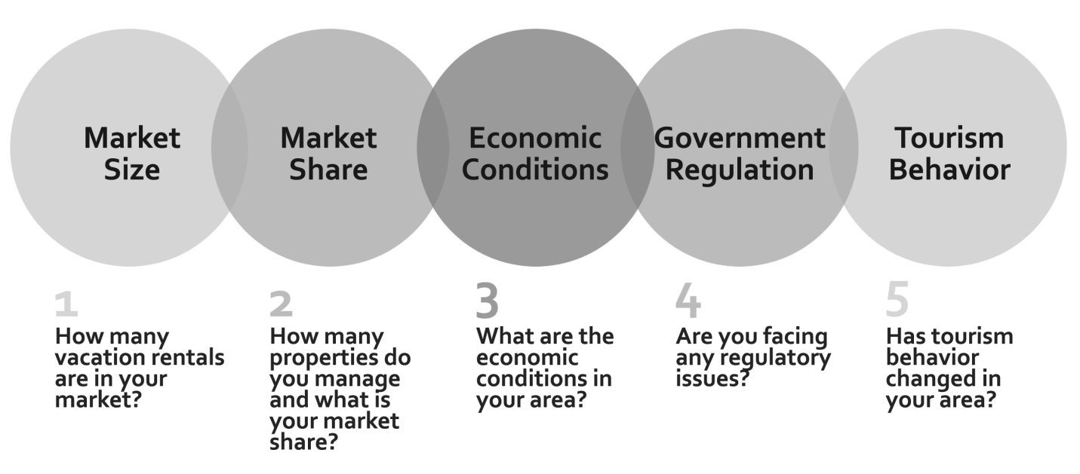

1. Total Inventory: How many vacation rentals are in your market? _________

You can get this likely from your CVB/DMO/Chamber/Hotel Tax/State Tourism Dept.

AL Gulf Coast Totals | Existing | 2012 | 2013 | 2014 | Future | Totals
Condos | 13,169 | 398 | 866 | 358 | 14,273 | 29,064
Hotels/Motels | 1,636 | 60 | 120 | 0 | 1,315 | 3131
Totals | 14,805 | 458 | 986 | 358 | 15,588 | 32,195

2. How many units do you manage? ________

3. What is your market share? _________

4. What are the economic conditions which you expect to impact 2015 performance (positive or negative)?

1.
2.
3.

5. Are there government regulations you expect to impact 2015 performance
(positive or negative)?

1.
2.
3.

6. What changes in tourism behavior do you expect to impact your 2015 marketing decisions (positive or negative)?

1.
2.
3.

COMPETITIVE ANALYSIS
> Let’s look at your competitors

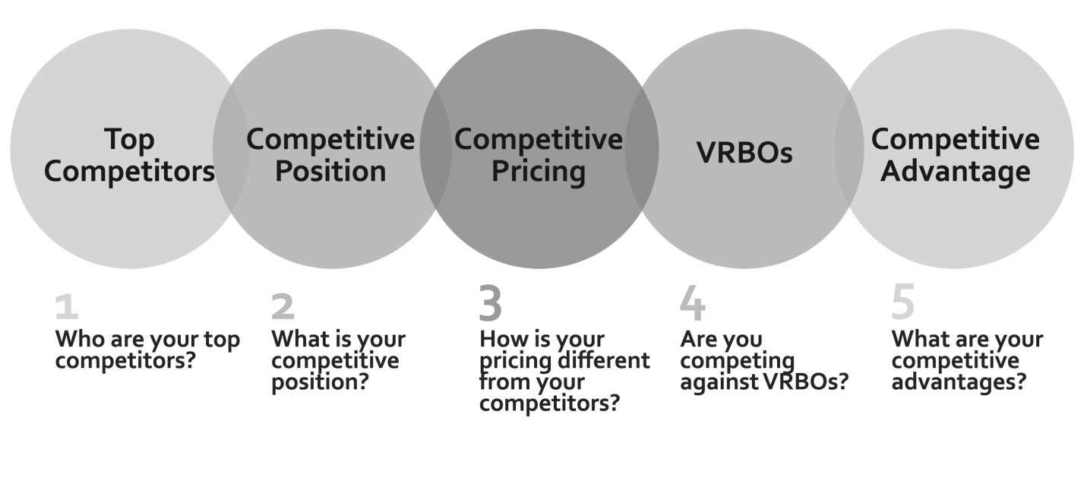
1. Who are your top competitors? How is your inventory different? How is your pricing different?

 | Competitor | Inventory Difference | Pricing Difference
1.
2.
3.
4.
5.

PRICING ANALYSIS
> Your vacation rental company’s pricing strategy

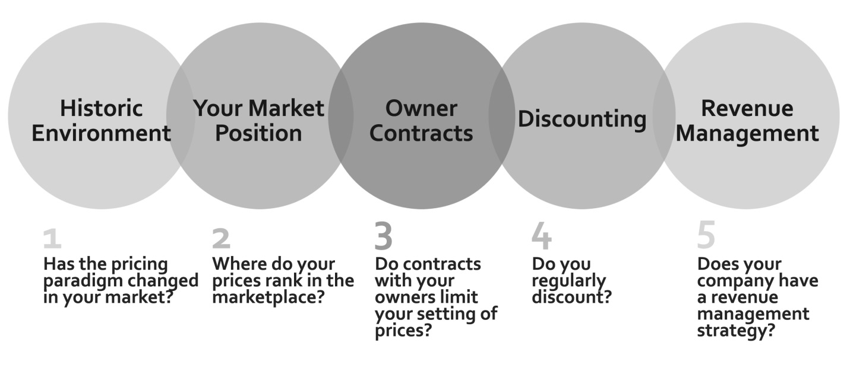
1. Has the pricing paradigm changed in your market? _________
2. Where do your prices rank in the marketplace? _________

3. Do contracts with your owners limit your setting of prices? _________

4. Do you regularly discount? _________

>> If so, what channels will you use to push out discounts? (Check all that apply)

____Website
____Email
____Direct Mail
____PPC
____Social
____Mobile
____Revenue Management
____Distribution
Other:_______________________________________________

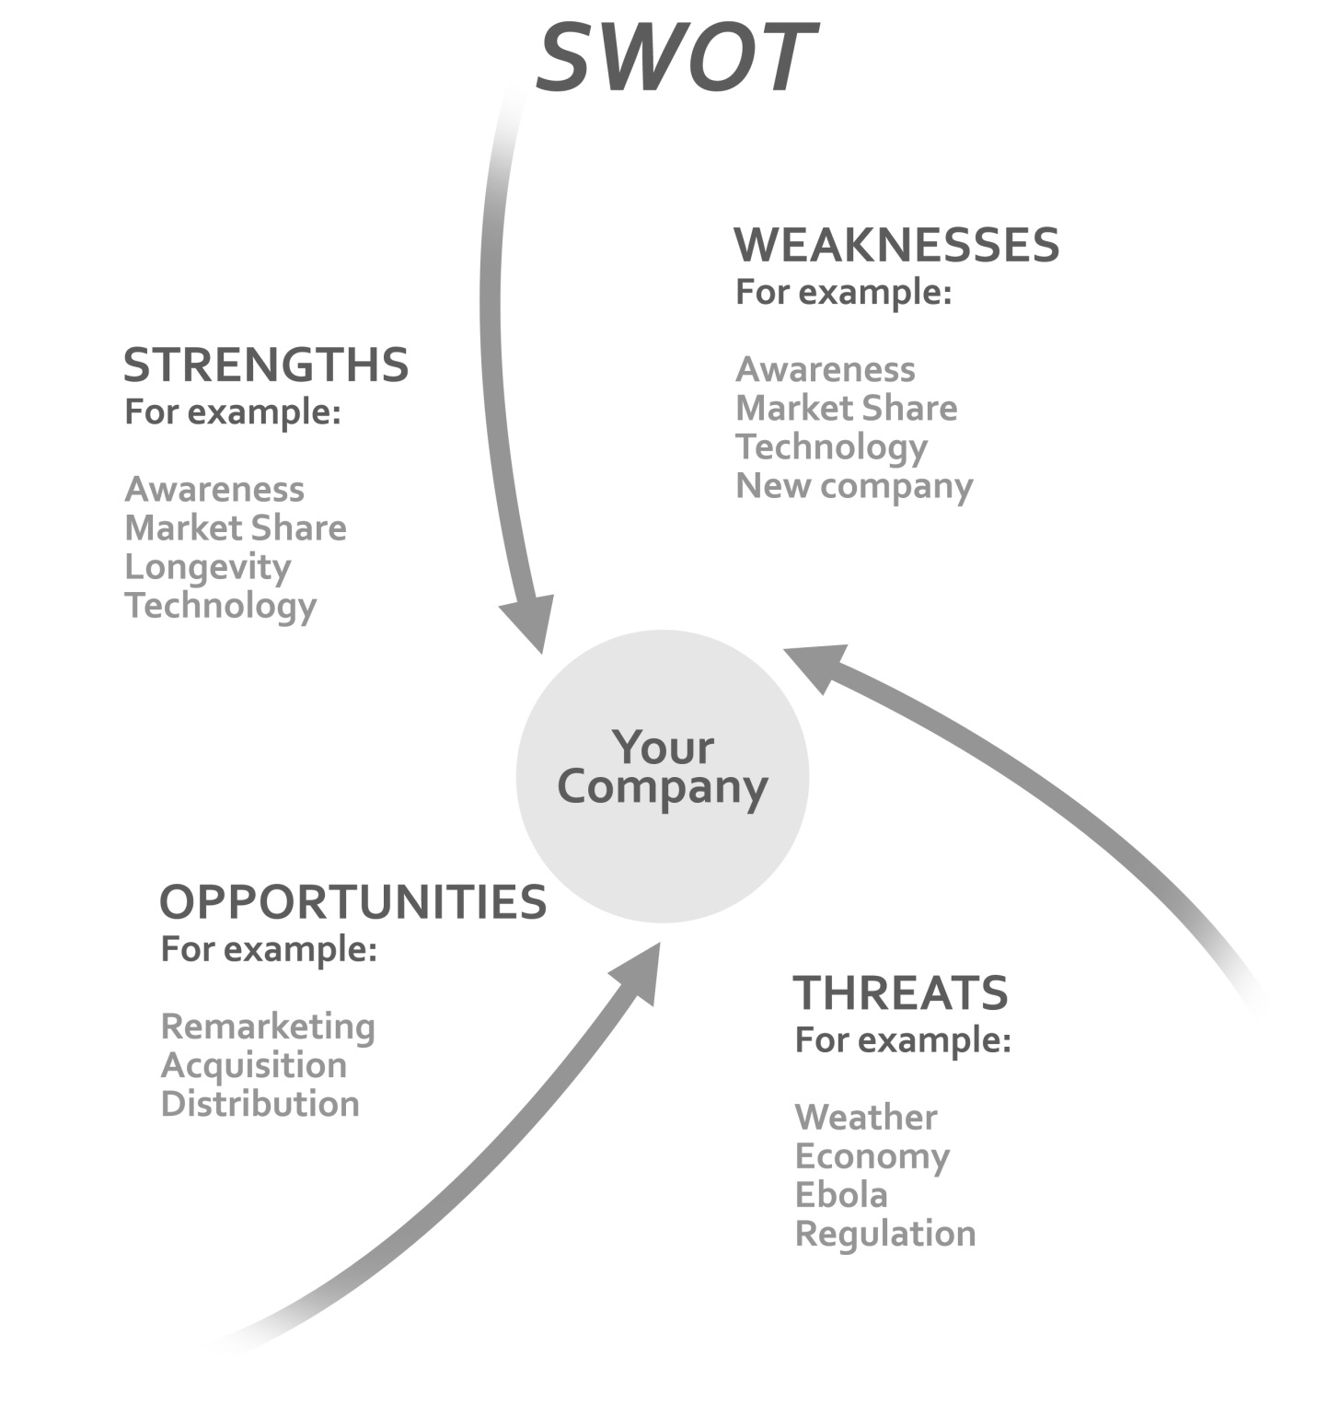

DETERMINING YOUR MARKETING BUDGET
> Typically vacation rental managers spend 5%-12% of rental
revenue on marketing

Properties | Rental Revenue |  |  | Marketing Budget
Average Annual Rental per Property | $15,000 | $27,000 | $35,000 | $15,000 |  | $27,000 |  | $35,000
 |  |  |  | Low (5%) | High (12%) | Low (5%) | High (12%) | Low (5%) | High (12%)
50 | $750,000 | $1,350,000 | $1,750,000 | $37,500 | $90,000 | $67,500 | $162,000 | $87,500 | $210,000
100 | $1,500,000 | $2,700,000 | $3,500,000 | $75,000 | $180,000 | $135,000 | $324,000 | $175,000 | $420,000
250 | $3,750,000 | $6,750,000 | $8,750,000 | $187,500 | $450,000 | $337,500 | $810,000 | $437,500 | $1,050,000
500 | $7,500,000 | $13,500,000 | $17,500,000 | $375,000 | $900,000 | $675,000 | $1,620,000 | $875,000 | $2,100,000
1000 | $15,000,000 | $27,000,000 | $35,000,000 | $750,000 | $1,800,000 | $1,350,000 | $3,240,000 | $1,750,000 | $4,200,000

> If your budget includes salaries, distribution costs and marketing technology, you might be on the higher end.
> If your budget does not include salaries, distribution costs and marketing technology, you might be on the lower end.
What did you spend in 2014?__________________
What is your overall marketing budget for 2015?_________________________

DETERMINING YOUR TARGET DEMOGRAPHIC

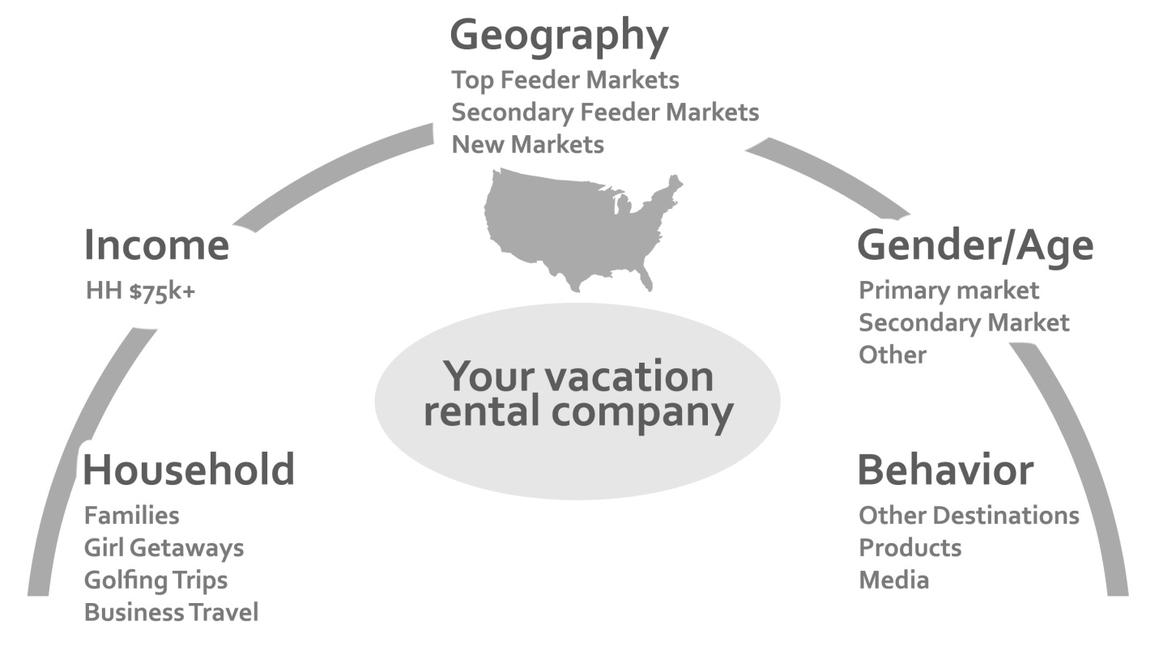
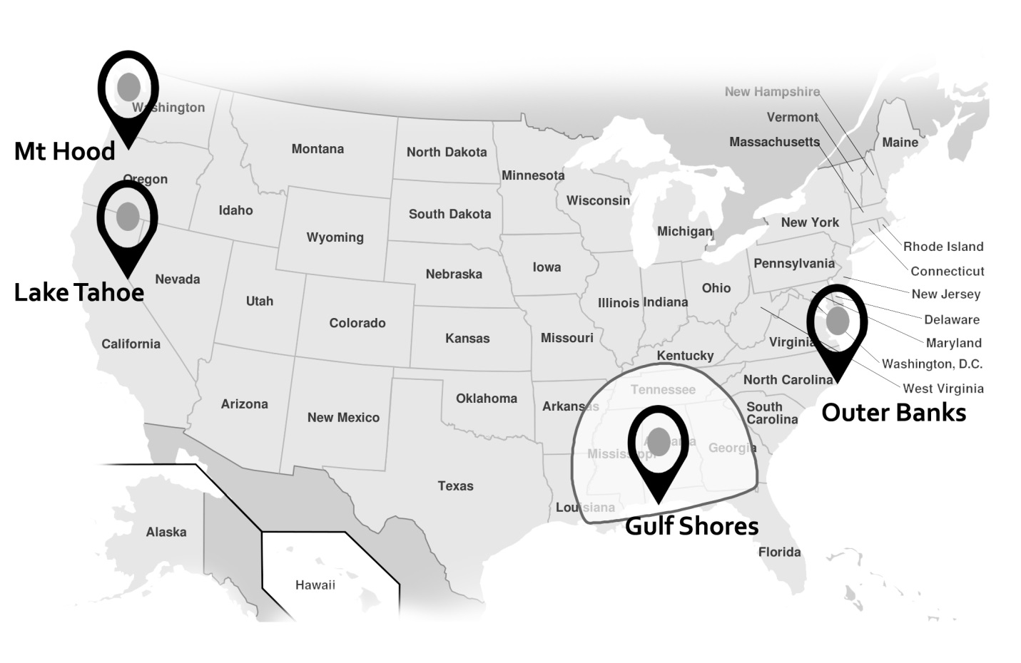
TARGET DEMOGRAPHIC

Household
Makeup
Families
Girl Trips
Golf Trips
Singles
Business Travel
Income
Level
HH Income $100K+

Gender/Age

Behavior
Activities
Where they travel
What products do they buy?
What media do
they see?

CONTENT MARKETING
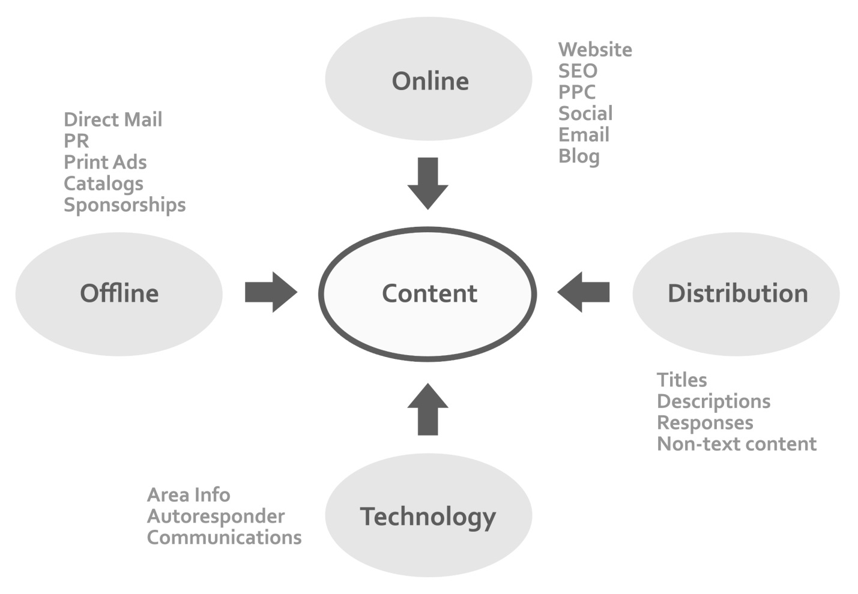
> Content creation: Key to all marketing channels and the most critical part of your vacation rental marketing plan.

1. How would you rate your content creation?

Content Creation | Rate 1-5
Website Property Pages (Titles, Descriptions)
SEO –Ongoing Content/Blog
Area Info
PPC Ad Copy
Social
Email
Print Ads
Catalog/Collateral
Autoresponder
Mobile App
2. What are your current content creation resources? What do you need? Outsource/Insource?
Current Content Creation Resources | What resources do you need? | Outsource/Insource?

MARKETING CHANNELS
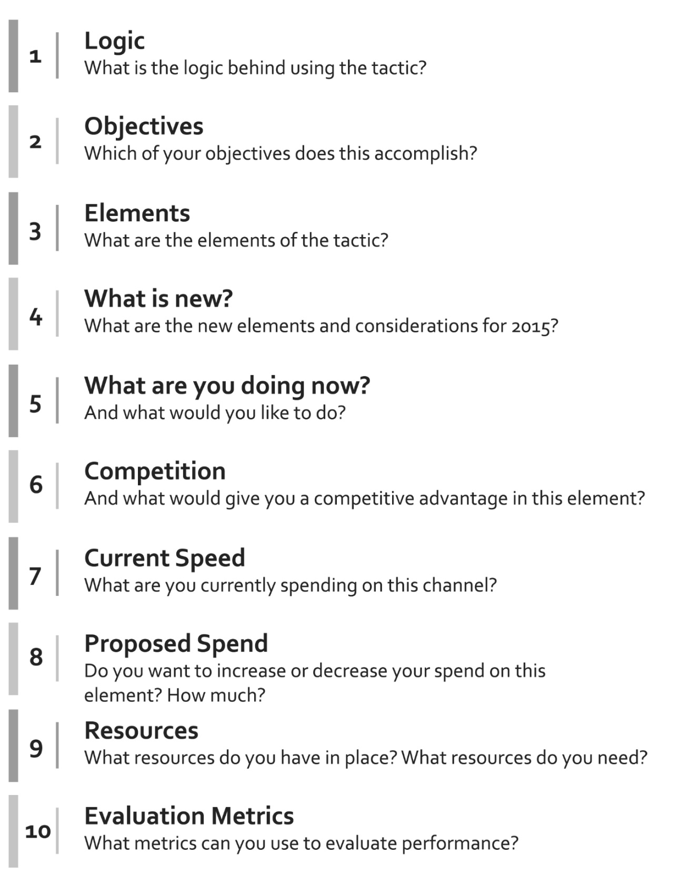
> How we will look at potential marketing tactics
ONLINE MARKETING
> Online Marketing Channels

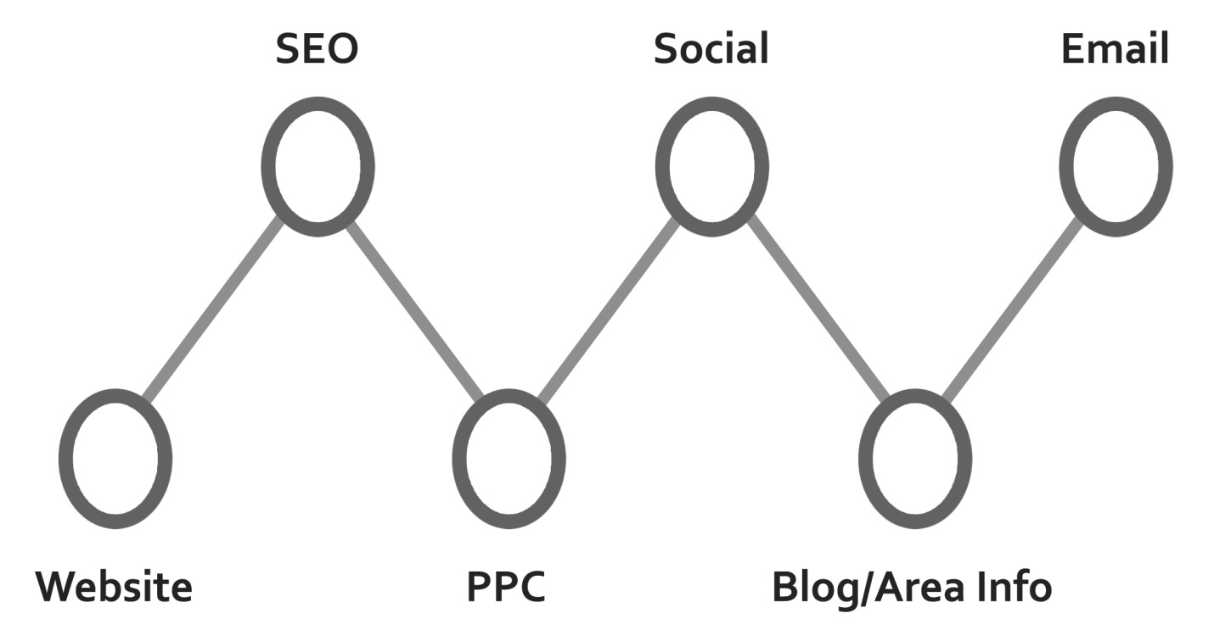

ONLINE MARKETING – Website

1. What are the goals/objectives and logic of improving website conversions?

Goals/Objectives | Logic

2. What are the elements of your internal marketing website strategy?
Home page:
Above the fold search
Above the fold destination and phone number
Ecommerce
Copy
Navigation
Property Pages
Area Info

What’s New:

 | 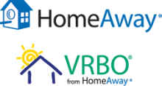 |  |  | Your Vacation Rental Website
Functionality
Single page view or tabbed layout | Both | Single Page | Both
Quoteable rates | Yes | Yes | Yes
Online booking | Yes | Yes | Yes
Online payments | Yes | Yes | Yes
Mobile-friendly | Yes | Yes | Yes
Response time | Measured, not in control | Measured, not in control | Measured, not in control
Click to chat | No | No | No
Advanced Search | Yes | Yes | Yes
Sort By | Yes | Yes | Yes
Comparison shopping | Yes | Yes | Yes
Property Appeal
Descriptive Titles | Measured, not in control | Measured, not in control | Measured, not in control
Descriptions | Measured, not in control | Measured, not in control | Measured, not in control
Professional Photos | Measured, not in control | Yes | Measured, not in control
Floor Plans | Links allowed | No | Links allowed
Suitable for: | Yes, under Features | Yes, under amenities | Yes, under accessibility and suitabilities
Neighborhood Photos | If owner supplies | Stock photos of neighborhood | If owner supplies
Mapping
Interactive Maps with attraction, restaurant and shopping | No | No | No
Searchable maps (near a specific address or an attraction) | No | Yes, but not fully functional | Yes, but not fully functional
Search results mapping | Yes | Yes | Yes
Reviews | Yes | Yes | Yes

3. What is your current strategy for improving your website design? What is your proposed strategy?

Current Strategy | Proposed Strategy

4. What are your top competitors doing? What can your competitive advantage be?

Competitor | Competitive Strategy

5. What are your current website resources? What do you need? Outsource/Insource?
Current Content Creation Resources | What resources do you need? | Outsource/Insource?

6. What is your current and proposed spend?

Current Spend | ↑ or ↓ | Proposed Spend

Evaluation Metrics

Conversion
Time of Page
Visits to conversion
Exit
ONLINE MARKETING – SEO

1. What are the goals/objectives and logic of SEO?

Goals/Objectives | Logic

2. What are the elements of your SEO strategy?

Page Structure
Titles
Description
Content
Mapping
Local
Google+
Authorship
Linking
Research

3. What’s New:
Links: http://www.searchmetrics.com/en/knowledge-base/ranking-factors/
http://searchengineland.com/seotable

4. What is your current strategy for improving your SE ranking? What is your proposed strategy?

Current Strategy | Proposed Strategy

5. What are your top competitors doing? What can your competitive advantage be?

Competitor | Competitive Strategy

6. What are your current SEO resources? What do you need? Outsource/Insource?
Current Content Creation Resources | What resources do you need? | Outsource/Insource?

7. What is your current and proposed spend?
Current Spend | ↑ or ↓ | Proposed Spend

Evaluation Metrics

Organic Traffic
New Visitors
Bounce Rate
Conversion
ROI
ONLINE MARKETING – PPC

1. What are the goals/objectives and logic of your PPC strategy?

Goals/Objectives | Logic

2. What are the elements of your PPC strategy?

Key word research
Ad copy
Landing pages
Exact Match and negative keywords
Seasonality
Quality Score
Geo-targeting
Bid Optimization
Monitoring
Display Network
Remarketing
Scheduling

Link: http://www.strathcom.ca/blog/2014/05/07/keyword-strategy-for-ppc-baby-steps/
3. What’s New:
> Ads Will Be More Obvious
> The Search Results Page Is Getting Prettier
> Image Ad Extensions
> Device

4. What is your current strategy for improving your PPC ranking? What is your proposed strategy?

Current Strategy | Proposed Strategy

5.. What are your top competitors doing? What can your competitive advantage be?

Competitor | Competitive Advantage

6. What are your current PPC resources? What do you need? Outsource/Insource?
Current Content Creation Resources | What resources do you need? | Outsource/Insource?

7. What is your current and proposed spend?
Current Spend | ↑ or ↓ | Proposed Spend

Evaluation Metrics

Click Through Rate (CTR)
Search Impression Share
Quality Score (QS)
Bounce Rate
Cost per Estimated Total Conversion & Mobile Click To Call Volume
Impressions and Clicks
Conversion
ROI (Include Labor Costs)

ONLINE MARKETING – Email

1. What are the goals/objectives and logic of your email strategy?

Goals/Objectives | Logic

2. What are the elements of your email strategy?

Platform
Lists
Content
Frequency
Segmentation
Lifecycle

3. What’s New:

> CRM tools
> Segmentation
> Lifecycle

4. What is your current strategy for email marketing? What is your proposed strategy?

Current Strategy | Proposed Strategy

5. What are your top competitors doing? What can your competitive advantage be?

Competitor | Competitive Advantage

6. What are your current email resources? What do you need? Outsource/Insource?
Current Content Creation Resources | What resources do you need? | Outsource/Insource?

7. What is your current and proposed spend?
Current Spend | ↑ or ↓ | Proposed Spend

Evaluation Metrics

Open rate
Click Through Rate
Click frequency
Conversion
ROI (Include Labor Costs)
OFFLINE ADVERTISING

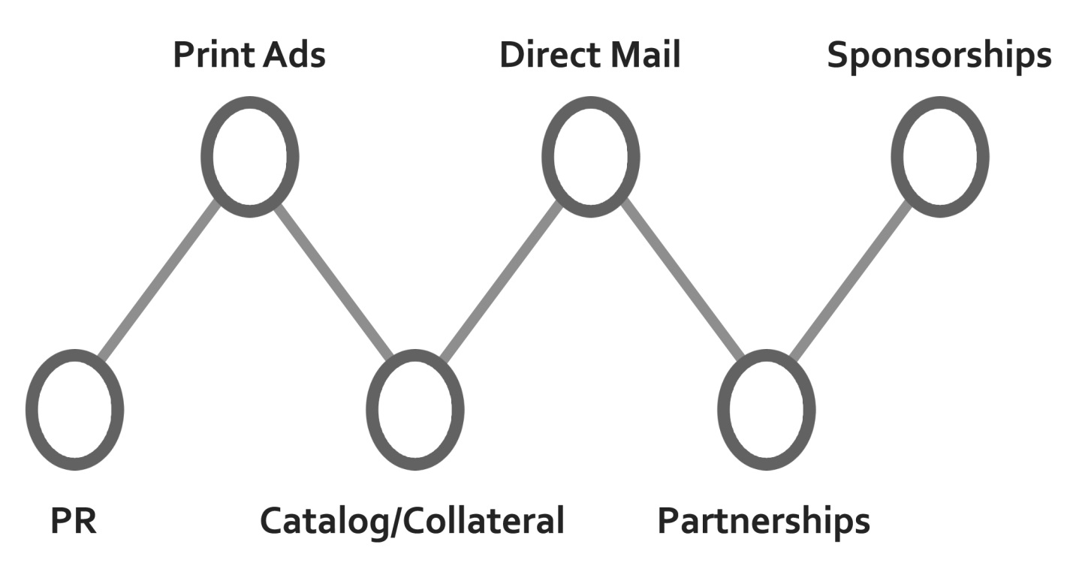

1. What are the goals/objectives and logic of your offline strategy?
Type | Goals/Objectives | Logic
PR
Print Ads
Catalog/Collateral
Direct Mail
Partnerships | Referrals, Branding, Awareness, Community, Ancillary Revenue
Sponsorship | Awareness, Branding, Community, Off-season revenue,

2. What are the elements of your offline strategy?
PR | Press releases, CVB, Media Contact, Media Opportunities
Print Ads | Newspaper. Magazine, Destination Guides
Catalog/Collateral | Vacation Guide, Sales Materials, In-Room Guides
Direct Mail | Segmented, Seasonally, Monthly, Quarterly, Geographically
Partnerships | Dining, Activities, Attractions, Services
Sponsorships | Events, Schools, Community, Chamber, Charities

3. What’s New:

> Market Specific

4. What is your current strategy for offline marketing? What is your proposed strategy?

Current Strategy | Proposed Strategy

5. What are your top competitors doing? What can your competitive advantage be?
Competitor | Competitive Advantage

6. What are your current offline resources? What do you need? Outsource/Insource?
Current Content Creation Resources | What resources do you need? | Outsource/Insource?

7. What is your current and proposed spend?
Current Spend | ↑ or ↓ | Proposed Spend

MARKETING – DISTRIBUTION
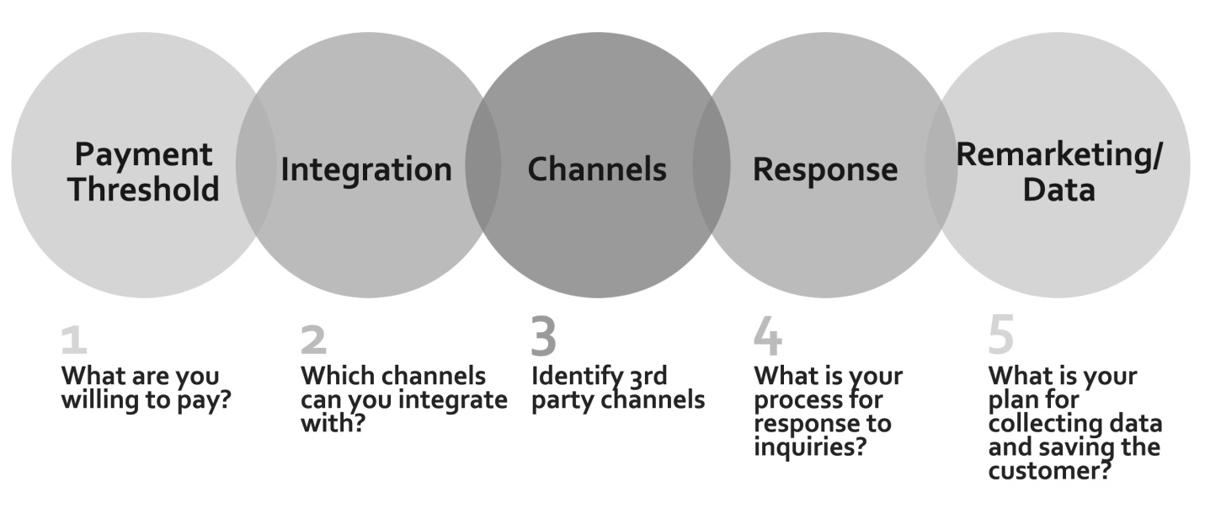
1. What are the goals/objectives and logic of your distribution strategy?

Goals/Objectives | Logic

2. What are the elements of your distribution strategy?

What are you willing to pay? | Press releases, CVB, Media Contact, Media Opportunities
What payment models will you use? PPS, PPL, PPB | Newspaper. Magazine, Destination Guides
What are your integration options? | Vacation Guide, Sales Materials, In-Room Guides
Which channels will you use? | Segmented, Seasonally, Monthly, Quarterly, Geographically
How many of your properties will you distribute?

What is your content distribution strategy | Dining, Activities, Attractions, Services
How will you respond to bookings | Events, Schools, Community, Chamber, Charities
How will you collect data and remarket to guests from distribution?

3. What’s New:

> New payment models (PPB)
> Autoresponders with AI
> Integration
> Booking.com

4. What is your current strategy for distribution marketing? What is your proposed strategy?

Current Strategy | Proposed Strategy

5. What are your top competitors doing? What can your competitive advantage be?

Competitor | Competitive Advantage

6. What are your current email resources? What do you need? Outsource/Insource?
Current Content Creation Resources | What resources do you need? | Outsource/Insource?

7. What is your current and proposed spend?
Current Spend | ↑ or ↓ | Proposed Spend

Evaluation Metrics

Inquiries
Conversions
ROI
Rebookings
MARKETING - TECHNOLOGY

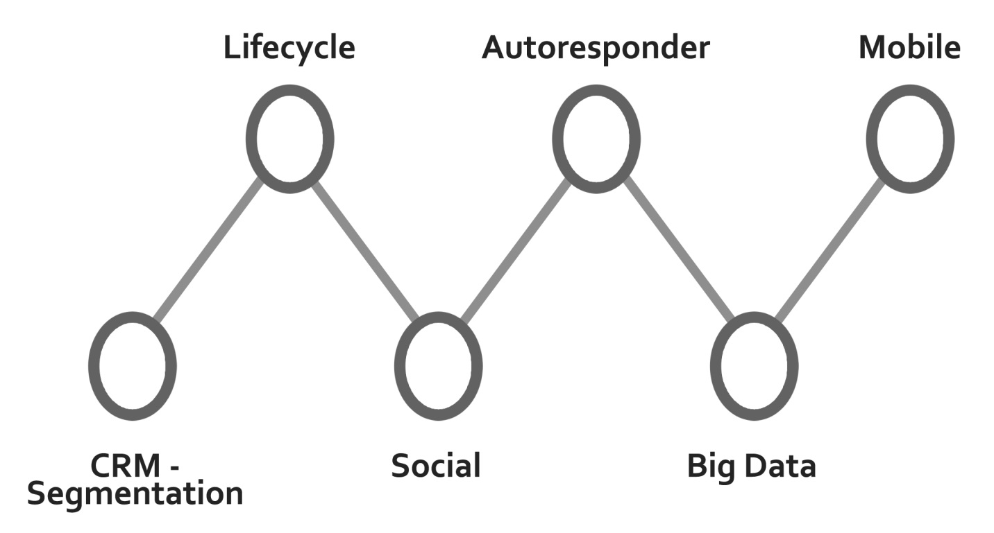

1. What are the goals/objectives and logic for marketing technology?

Goals/Objectives | Logic

2. What marketing technology will you use?

Technology | New or existing | Cost
CRM (with list segmentation)

Lifecycle marketing

Autoresponder

Social

Data Mining

Mobile

3. What’s New:

> Vacation Rental CRM
> Lifecycle Messaging Tools
> Autoresponders with AI
> Data Mining
> Revenue Management
> Mobile Tools

4. What is your marketing technology usage? What is your proposed strategy?

Current Strategy | Proposed Strategy

5. What are your top competitors doing? What can your competitive advantage be?

Competitor | Competitive Advantage

6. What are your current technology resources? What do you need? Outsource/Insource?
Current Content Creation Resources | What resources do you need? | Outsource/Insource?

7. What is your current and proposed spend?
Current Spend | ↑ or ↓ | Proposed Spend
